Name- Caron Deula
Student ID- 24071125
Section- ‘C’

PART 1 [50 marks]

1. The perimeter of a rectangle with length 9 & width 6

Output:

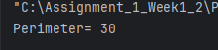
- Python is great, it’s wild!

Output:

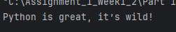

3. 2 to the 10thpower

Output:

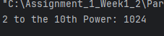

4. 7 factorial minus 5 factorial

Output:

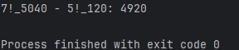

5. Your forename multiplied by 5

Output:

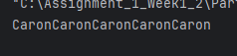

6. Your name left justified 15 spaces

Output:

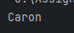

7. PI to 5 decimal places

Output:

8. 200 modulus 12

Output:

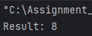

9. 7.2 as an integer value

Output:

10. The Unicode encoding for your name

Output:

